1.12.3-ALG pushNotificationGateway() Algorithm
Purpose:
This algorithm manages the delivery of push notifications to a user's registered devices. It validates that device tokens are available, sends the notification message to each device, tracks successful and failed deliveries, and returns a summary of the notification request, including delivery status and any errors encountered.
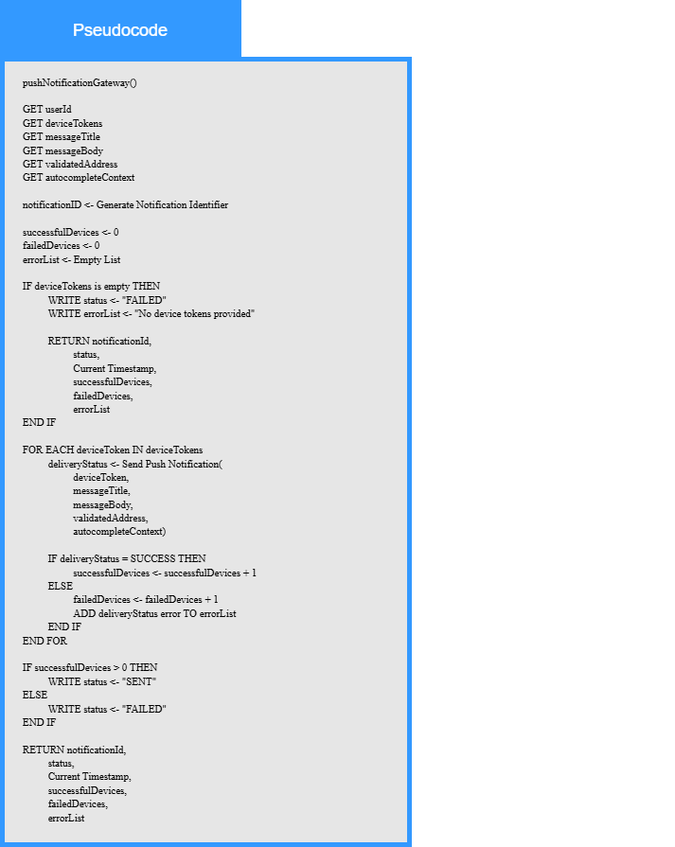
Local Data:
notificationId : Notification Identifier
successfulDevices : Number
failedDevices : Number
deliveryStatus : Status
errorList : List of Error Messages

